New Hire Roadmap

V3.0 2026

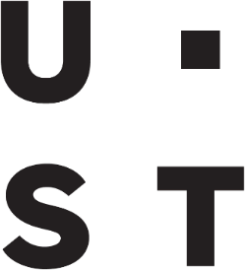


ust.com

Copyright and Confidentiality

Copyright © 2024 by UST Global Inc. All rights reserved. This document is protected under the copyright laws of United States, India, and other countries as an unpublished work and contains information that shall not be reproduced, published, used in the preparation of derivative works, and/or distributed, in whole or in part, by the recipient for any purpose other than to evaluate this document. Further, all information contained herein is proprietary and confidential to UST Global Inc and may not be disclosed to any third party. Exceptions to this notice are permitted only with the express, written permission of UST Global Inc.
UST® is a registered service mark of UST Global Inc

UST
5 Polaris Way,
Aliso Viejo,
California 92656
United States

Revision History
Date | Version | Description | Author | Reviewed By
April 2, 2024 | 1.0 | Document and Policy creation | HR – Employee  Experience  Team | Human  Resources
May 29, 2024 | 2.0 | Edited Checklist and Colors Program Content | HR – Employee  Experience  Team | Human  Resources
May 2025 | 2.1 | Updated Links | HR Employee  Experience  Team | Human  Resources
August 2025 | 2.2 | Updated UST Square links | HR Employee  Experience  Team | Human  Resources
December 2026 | 3.0 | Update NHO and other onboarding info | HR EET | HR

Contents

Introduction 4
Notes and Caveats 4
Contact Information 6
Helpful Links 7
Frequently Asked Questions 8
Referrals 9
Ethics Point 11
Colors of UST 12
UStar 13
Notes and Questions 14

Introduction
Welcome to UST! We are thrilled to have you as part of our team. This document serves as your New Hire Playbook, providing you with a comprehensive guide to ensure a seamless onboarding experience. Our goal is to equip you with the necessary tools and knowledge to thrive in your new role and contribute meaningfully to the success of UST!

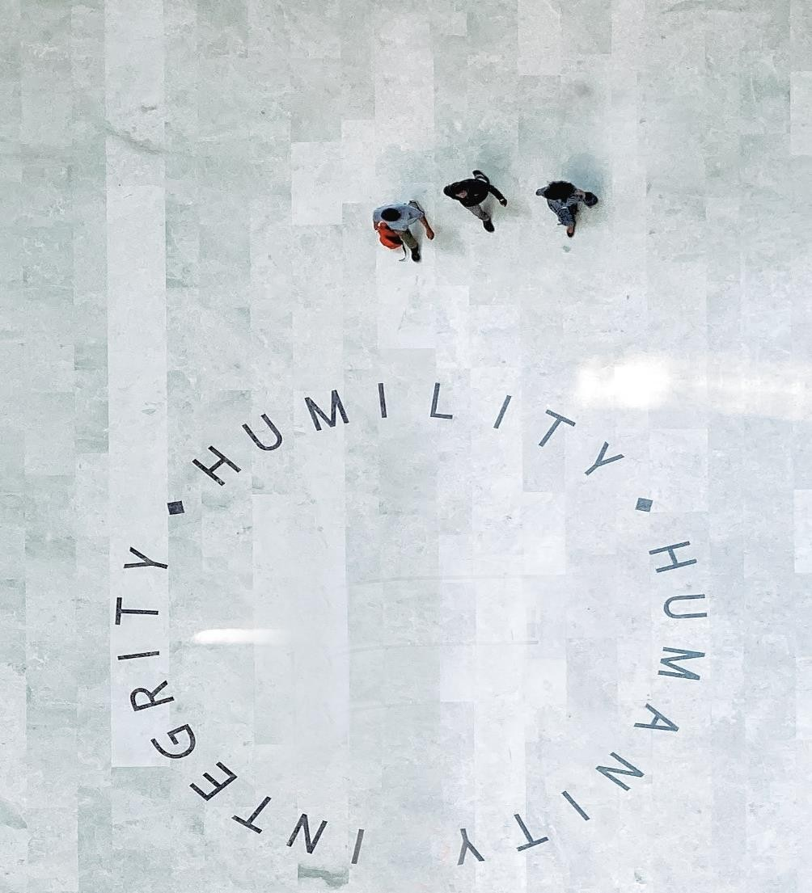

Notes and Caveats
This document is designed to provide general insight into expectations and resources a new hire. This is not designed to trump project-specific goals and educational needs, rather designed to supplement those goals to give our new associates the best possible set of tools and resources to ensure their success within UST. Exceptions to the above guidelines can and will be made on a case-by-case basis to ensure that all project-related work can be completed in a timely manner. However, all possible effort should be expended to adhere to this list of guidelines.

New Hire Checklist

□ Set up company provided equipment
□ Access UST Square and review the UST
- Complete Section 1 of I9Square US Onboarding site
- Access UST email □ Access UST email
First • Set up company provided equipment
- Complete email signature line □ Set-up email signature line (Template can
Day • Review helpful linksbe found in the “Helpful Links” below)
- Set up Microsoft Teams □ Complete Section 1 of I9
- Meet with Reporting Manager
□ Review helpful links
□ Access Microsoft Teams
□ Access Timesheet Portal
- Access Timesheet Portal □ Attend New Hire Orientation
First • Attend New Hire Orientation □ Enter demographic details into Workday
- Complete Section 2 of I9
- Enter demographic details into Workday□ Start the Onboarding Journey in Workday
Week • Introduction to NorthStar and project to confirm your personal details within the expectations HRIS system
□ Meet with your manager
First 30 Days |  | □ Access ADP and Register account  - Access ADP and Register account □ Access Principal 401K  - Access Principal 401K  - Review and Complete benefits □ Review and Complete benefits enrollment  - Review and Document NorthStar□ Review and Document goals in Workdaygoals

Contact Information

Team | Information | Contact Info
iSolve Helpdesk Team | Support for UST credentials and applications | ISHelpdesk@ust.com  ISHelpDesk on Teams  949-600-5511
North America Payroll Team | Team to support employees in the US on  different payroll related queries, including  W2s/W4s and ADP | PayrollQueries.US@ust.com
US HR Team | Front-end HR Support Team to support employees on HR queries | HR.US@ust.com
US Benefits  Team | Support for your employee benefits, accommodations, workers compensation, and leaves of absence | Benefits.US@ust.com
GAMA Helpdesk | Support for your learning/credential inquiries | GAMAHelpdesk@ust.com
Timekeeping Systems | Support for your timekeeping inquiries | U&UST:  UandUSTSupport@ust.com  ADP: USNon-  ExemptTimesheet@ust.com

Helpful Links

Site | Link
UST Square – UST SharePoint | https://ustsquare.ust.com/home
UST Policy Portal | https://policymgmtsys.ust.com/home
Learning Hub | https://gamapls.ust.com/LearningHUB/Home
KnowB4 Training – ISMS Trainings | https://training.knowbe4.com/ui/login
Career Velocity – Career Planning | https://ust-career-edge.edgenetworks.ai/#/pages/organization-hierarchy
iSolve – IT Helpdesk Support | https://ustglobal.service-now.com/ust
Concur by SAP – Travel bookings | https://us2.concursolutions.com/home
Exempt Timekeeping System (salaried, exempt) | https://timesheet.ust.com
Non-Exempt  Timekeeping System  (hourly, non-exempt) | https://portal.adp.com/
Workday - HRMS | https://wd5.myworkday.com/wday/authgwy/ust/login.htmld
Signature Line Template | https://brandportal.ust.com/content/global/ust-brand-portal/brandingdocuments.html/content/dam/ust/global/ust-brand-portal/brandtemplates/email-signature
ADP – to view pay stubs | https://my.adp.com/

Frequently Asked Questions

SYSTEMS
- Where can I find UST’s SharePoint?
  - UST Square - Home - UST Square
- I am having issues with my UST laptop and or systems where do I go?
  - iSolve
- Does UST have an IT Helpdesk?
  - Contact ISHelpdesk@ust.com, ISHelpDesk on Teams, or call 949-600-5511
- I am an Exempt employee having issues with my U&UST timekeeping system. Who do I contact? o UandUSTsupport@ust.com
- I am a Non-Exempt employee having issues with my ADP Workforce Manager timekeeping system. Who do I contact? o USnon-exempttimesheet@ust.com

PAYROLL
- How do I register an account with ADP to access my payslips? o On My ADP, and enter the registration code: USTECH-adp
- What do I do if I miss the ADP time sheet submission deadline?
o Contact the US Payroll team via email at payrollqueries.us@ust.com, please ensure your manager is on cc for visibility.

BENEFITS
- Where can I find information on benefits and enrollment?
o Go to https://ustsquare.ust.com/home o Locate the “Search Bar” in the upper left hand corner o Type “US Benefits” and select the “US Benefits Site” option.
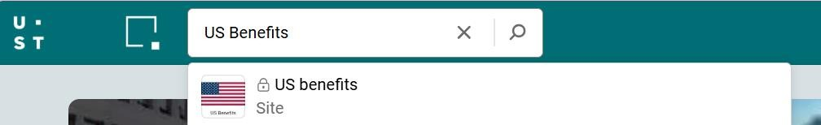
- When will I have access to enroll in my benefits? o You will be able to register in 5-7 business days from your date of hire.
- How long do I have to sign up for my benefits?
o The enrollment window closes at 11:59ET 30 days after Date of Hire. Please do not wait until the last minute to access the benefits platform or enroll.
- When do my benefits go into effect?
o If you are a regular employee your benefits will be effective on your date of hire. o If you are a temporary employee your benefits are effective on your 46th day of hire
- Do I have to enroll in benefits?
o As a regular employee you must actively either waive or decline your benefits. If you do not you will be automatically enrolled in the high deductible health insurance plan.
- Am I eligible for a retirement plan? o Yes, all employees are eligible. Eligibility begins on the 1st of the month following 30 days. All employees are automatically enrolled for 4%.

- How do I enroll or opt out of contributing to the 401K?
  - You must have had at least one paycheck prior to attempting to register at www.principal.com

- Where can I find information on Time Off and Holidays?
  - Please refer to the Employee Handbook on the UST Policy Portal https://policymgmtsys.azurewebsites.net/home

- When is the New Hire Onboarding hosted?
  - The New Hire Onboarding session is hosted on Wednesdays from 8:00-9:30am PST. During this session you will learn more about UST, its policies, and receive an extensive overview of the benefits offered and the enrollment process.

Referrals

UST believes in the strength of our team and the power of connections! That’s why we encourage our employees to utilize our Employee and Account Referral programs.

Employee Referral
Our Employee Referral Program is designed to harness the power of our talented team in identifying exceptional individuals who could be a great fit for UST!
How Does It Work?
- Keep an eye out for talented individuals within your network who would thrive at UST.
- Refer the candidate to our recruitment team by submitting their information through our referral portal.
- The Employee Referral Team will contact the referring party and referred candidates with additional updates.

Why Participate?
- Contribute to Our Growth: Your network is a valuable resource, and your referrals can help us expand and strengthen our team.
- Earn Exciting Rewards: Beyond the satisfaction of bringing in top talent, if eligible, employees can earn up to $3,000!

Access Here: Employee Dashboard (ripplehire.com)

Account Referral
Our New Client Discovery Program is designed to aid the business growth of UST by encouraging associates to refer business leads!
How Does It Work?
- Stay alert to potential business connects within your network to contribute to UST’s success.
- Submit the Business contact through our ColumbUS referral portal.
- All the business lead details shared by associates will be evaluated by ColumbUS team and will be assigned on individual priority.

Why Participate?
- Contribute to Our Growth: Your network is a valuable resource, and your referrals can help us expand and strengthen our organization.
- Earn Exciting Rewards: Your connections could make you eligible for our account incentive program!

Access Here: ColumbUS (sharepoint.com)

Ethics Point
Our values of Humility, Humanity and Integrity have been the foundations of our corporate culture as we work to transform lives. UST is committed to providing a work environment free of discrimination and maintains a strict policy prohibiting unlawful harassment. It is your duty as a UST employee to raise any concerns to your supervisor or to the HR Department. If you are uncomfortable raising it to a person you have the option to go to the values hotline.
Each UST employee has access to our values hotline, EthicsPoint. EthicsPoint is a comprehensive and confidential reporting tool to assist management and employees to work together to address fraud, abuse, and other misconduct in the workplace. We believe that our employees are our most important asset. By creating open channels of communication, we can promote a positive work environment and maximize productivity. We have provided a link and screenshot below where you can record your complaint and submit it anonymously. Once submitted, this request goes to a team comprising representatives from HR, Legal and Governance risk and compliance.

Learn more here: https://secure.ethicspoint.com/domain/media/en/gui/25206/index.html

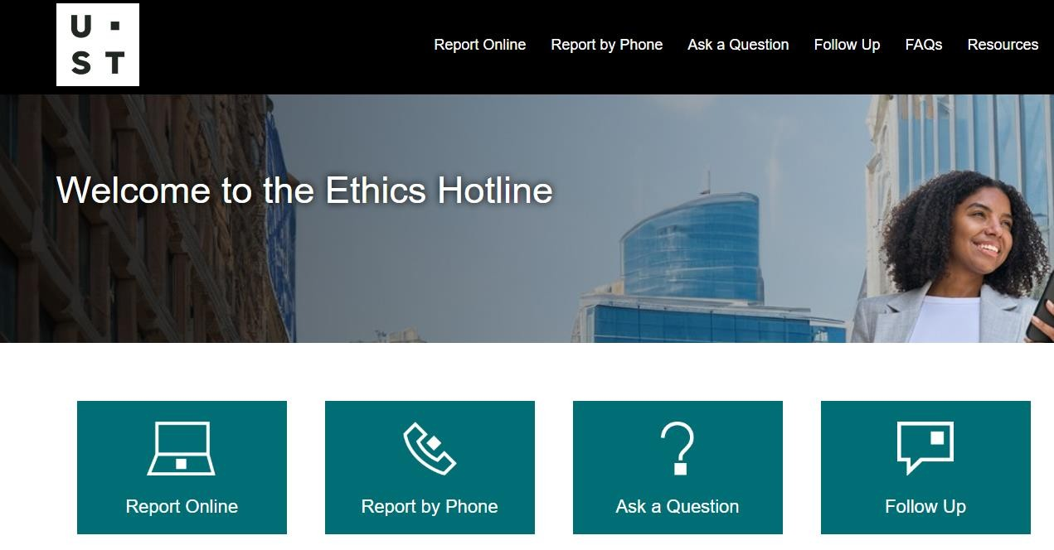

Colors of UST
The Colors of UST are volunteer-driven teams that empower our employees to improve both within our company and in the communities, we call home. Each Color initiative is designed to enable employees to partner on sustainable goals.
Employees of UST can choose to spend their time with one or more color groups of their preferences and interests. You will begin to receive emails from the Colors Framework, feel free to sign up for any session that interests you. While this program is largely based in India, we are diligently working to expand the events & sessions to US timing.
 | Global Branding  The Color gold initiative empowers UST employees worldwide to champion the UST brand. The global brand team ambassadors tell the UST story across the globe, sharing our 'special sauce' while making sure that we communicate our strong sense of purpose.
 | Growth  At UST, personal and professional development opportunities are a part of our individual and combined success. The growth team develops programs to help employees hone their skills and grow individually.
 | Innovation  These creators and problem solvers partner with UST's innovation initiatives to run hackathons, design thinking workshops, and seminars that help UST constantly push technology boundaries for our clients.
 | Digital Organization  The digital organization team improves employee experience by transforming UST's internal processes with digital automation initiatives.
 | People  The people team develops health and wellness programs, family events, and opportunities for fun to improve the employee experience, ensuring that UST provides a positive work environment for all.
 | Quality and Speed  By optimizing processes and identifying reusable assets, the quality and speed team internally improves UST's work quality and efficiency.
 | Community Relations  The rose team focuses on strengthening communities, empowering community members, and building collectively for boundless impact through global volunteering initiatives.

Learn More about the Colors of UST program: Colors of UST (UST Square)

UStar

UST is committed to fostering a positive and appreciative workplace culture. With our innovative recognition system Ustar you have the power to recognize and celebrate your colleagues’ outstanding contributions!
Every time you give a Ustar to a fellow team member, you not only acknowledge their hard work but also contribute to their valuable points. As you collect these points, you unlock an array of rewards ranging from Fashion, Electronics, Gift Cards/Vouchers, Home Goods, Health and Beauty, plus so much more!

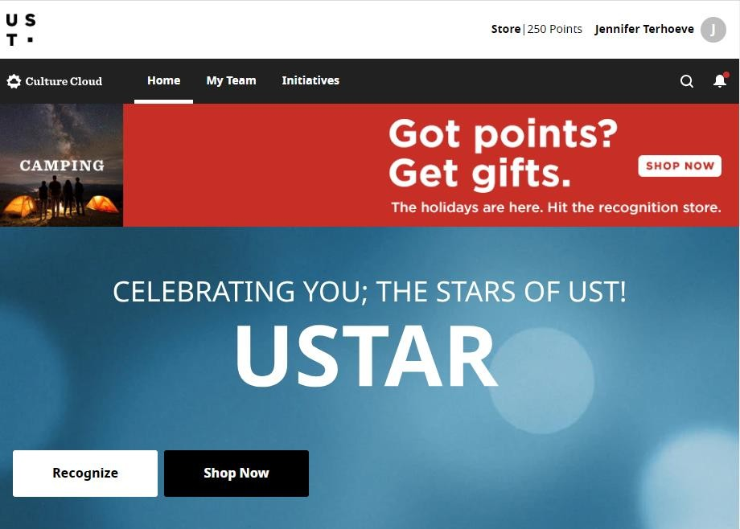

Notes and Questions

Together, we build for boundless impact

ust.com
